

American International University-Bangladesh (AIUB)

**Department of Computer Science  
Faculty of Science &Technology (FST)**

**Software Development Project Management**

**Section: A**

**Vromon – Community Based Travel Services**

Under the supervision of

**Md. Anwarul Kabir**

Table of Contents

1. **Introduction……………………………………………………………………………………………………………………3**

**2.0 Project Title…………………………………………………………………………………………………………………….3**

**3.0 Objective…………………………………………………………………………………………………………………………4**

**4.0 Justification…………………………………………………………………………………………………………………….4**

**5.0 Systems overview(Use Case DIAGRAM)…………………………………………………………………………..5**

**6.0 Stakeholder Analysis……………………………………………………………………………………………………….7**

**7.0 Feasibility Study………………………………………………………………………………………………………………8**

**8.0 System Component…………………………………………………………………………………………………………9**

**9.0 Process Model to be followed……………………………………………………………………………………….10**

**10.0 Effort estimation……………………………………………………………………………………………………………11**

**11.0 Activity Diagram……………………………………………………………………………………………………………13**

**12.0 Risk Analysis………………………………………………………………………………………………………………….14**

**13.0 Budget For the project………………………………………………………………………………………………….14**

**14.0 Conclusion…………………………………………………………………………………………………………………….15**

1. **Introduction:** The desire for internet services has grown to historic heights in this world of technological innovation. Additionally, the COVID-19 pandemic has clearly highlighted the advantages of moving operations online. These benefits are equally relevant to Bangladesh's tourism sector. In this project, we will design a web-based platform that will integrate the services that travelers and transport business organizations desire. The software program may also consist of capabilities inclusive of unique statistics on traveler destinations, looked after through branch and location name. This statistics may also consist of areas, modes of delivery, feasible routes, public delivery and resort accommodation, feasible monetary need, etc. This information will provide clients and visitors with a detailed outline as well as an estimated cost for traveling to the places of their selection. Customers may then select a trip and buy tickets, cars, or lodgings depending on their affordability. The platform will allow travelers to interact with tour operators and small property owners. Hotel, property, bus, vehicle, rail, and airline owners will be able to use it as a hotel system. Travelers will be able to get in touch tour companies using this platform. Tourists will be able to converse with travel companies and small landlords through the platform. Extreme Programming (XP) is the software development approach that will be employed for the project. This is an iterative method to software development that is adaptable and responsive to changing requirements. Because the project will be based mostly on user input and evaluations, there will be dynamic requirements and frequent product revisions. Extreme Programming can give the necessary flexibility to deal with changes.

**2.0 Project Title:** The title of our project is “**Vromon – Community Based Travel Services**”. It basically is a web-based application that aims to combine the services desired by tourists as well as travel related business organizations.

1. **Objectives:** “Vromon – Community Based Travel Services” is a web-based application that aims to combine the services desired by tourists as well as travel related business organizations. This application will be integrating features like information about places to travel to, classified by divisions and district names. This information can include pictures, ways to travel, possible routes to reach there, transportation and hotel facilities, possible budget requirements etc. This information will allow the customers and tourists to get a good overview as well as a cost estimation to travel to the destinations they are interested in. The users can then choose the route and book tickets, car or hotels based on their cost limits**.** The vision of this application is to be established as a trusted travel solution provider for the travelers as well as the traveling related business owners of Bangladesh. The mission of this platform is to provide traveling related information and a one-stop service for the travelers and a platform for the business owners to reach customers easily.

Our goal is to:

* Provide centralized information for all districts of Bangladesh.
* Provide tourists with travel related services like transportation, ticket and hotel booking, etc.
* Provide traveling related business owners with a platform to reach their customers.

1. **Justification:** Tour Group Management is very beneficial for travel business. They are written below:

* It is very helpful for work organized way.
* It is more secured and payment system is also easy and secured.
* It helps to management team to reduce workload.
* This is fast working process.
* Business remains open 24/7.
* At any time customer can book.
* Customers can easily cancel their booking within given deadline.
* Increases business credibility with the better user experience because it simplifies the booking and reservation processes.
* This system will provide to connect directly customers and agent through internet.
* Provide facilities to modify and delete tourist’s data as well as client data.
* Our system will provide feedback mechanism for tourist.
* Our software system will provide Inbound and Outbound Tour packages.
* It will display attractive tourist places.
* This system give a variety of travel services that will sure to match all client’s priorities.
* Our online tour management system help to make strong relationship with customer so that they can enjoy that holiday of their dreams.
* This system will provide display platform in where a tourist can find their tour places according to their choices.

**5.0 Systems Overview**

**Use Case Diagram:** In this application, there will be four types of users. They are tourists, business owners, administrative team members and the system itself. Subscribed tourists will be a specialized type of user who will have access to ad-free experience and discounts. Tourists will be able to search travel destinations, choose routes, book hotels and transportation or other community services. Business owners will be able to add business details and pay due amount to the platforms. Admins will be in charge of keeping track of the payments and verification of users. The system will be coordinating communication between tourists and business owners as well as analyzing and recommending destinations and maintaining history.

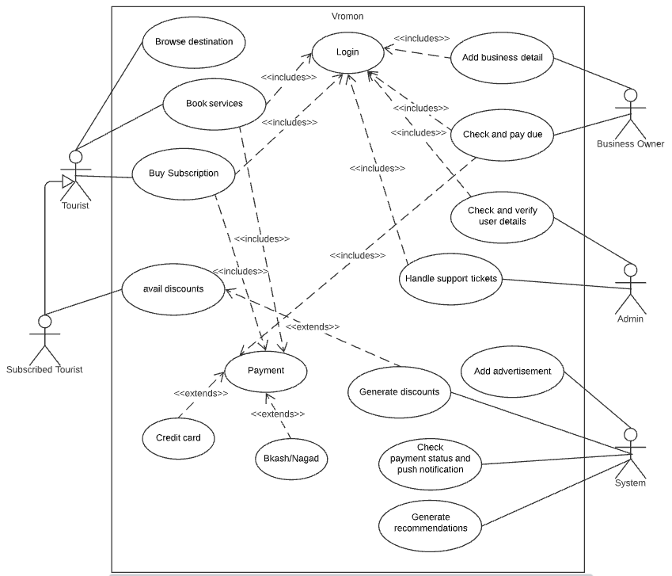

Figure: Use Case Diagram

**6. Stakeholder Analysis:** We system have two stakeholders. First one is internal and second is external stakeholder.

* **Internal Stakeholder**: group or people who directly within the business, employees, owners, managers. In our project internal stakeholder will be:

1. Employee: Mainly employee will be primary internal stakeholder. Because Employees have significant financial and time investments in the organization, and play a defining role in the strategy, tactics, and operations the organization carries out.
2. Manager: Manger are internal stakeholder because Employees of the company are invested in the company's performance to ensure they continue to be paid and retain their jobs. Depending on the nature of the business, employees may also have a health and safety focus.
3. Developer: They have the technological expertise necessary to advise executives on which features are feasible and how long each would take to build.
4. Shareholder: They are tied to your company through the stocks they own. As such, they're directly impacted by projects that influence stock prices.

* **External stakeholder:** External stakeholders are those who do not directly work with a company but are affected somehow by the actions and outcomes of the business.

1. Suppliers: Suppliers provide the raw materials or components that a company uses to create its products. A business may depend on one particular supplier that produces a superior or rare good, in which case the supplier has heightened importance.
2. Bank and lenders: Lenders are external stakeholders because they have a financial interest in the success of the project for which they lend money, as well as potential reputation, insider, networking etc.
3. Government: - The government is an external stakeholder in all businesses. In fact, it is considered one of the major stakeholders since it collects taxes from these establishments in the form of corporate income tax and income tax from the employees of the company.
4. Customer: - The Customers can be considered as the most important external stakeholders. These are the people who will consume the end products or use the services of the company. They, therefore, decide whether a business succeeds or not, even though they are not concerned with its day-to-day running.

**7.0 Feasibility Study:** Preliminary investigation examines project feasibility, the likelihood the system will be useful to the organization. The main objective of the feasibility study is to set the technical and financial feasibility for adding new modules and debugging old running system. All systems are feasible if they are given unlimited resources and infinite time. There are aspects in the feasibility study portion of the preliminary investigation:

* Technical Feasibility
* Financial Feasibility

Technical Feasibility: The technical issue usually raised during the feasibility stage of the investigation includes the following:

* Does the necessary technology exist to do what is suggested?
* Does the proposed equipment’s have the technical capacity to hold the data required to use the new system?
* Will the proposed system provide adequate response to inquiries, regardless of the number or location of users?
* Can the system be upgraded if developed?
* Are there technical guarantees of accuracy, reliability, ease of access and data security?

Financial Feasibility: A system can be developed technically that will be used if installed must still be a good investment for the organization. In the financial feasibility, the development cost in creating the system is evaluated against the ultimate derived from the new systems. Financial benefits must equal or exceed the costs. The system is equally feasible. It does not require any additional hardware or software.

**8.0 System Component:** There will be 3 types of users of this application. They are:

* Tourists who will,
* Browse for information about different travel destinations.
* Avail different travelling services.
* May subscribe to a premium membership.
* Travel Business owners who will,
* List their business for the tourists.
* May have multiple businesses listed.
* Pay a percentage of the payment from the tourists to “Vromon.
* Administrative team member who will,
* Verify validity of the businesses through E-Trade License and E-TIN numbers.
* Access information about bookings.
* Access user or business information when necessary.
* Coordinate with the support team to resolve issues related to user accounts.

**Application features:** The application will include but is not limited to the following features:

* Travel destination information based on districts
* Travel location suggestion based on popularity
* Search options based on districts
* Options for selecting different travel services
* Ticketing based on cost, type and routes
* Subscription for premium membership
* Special offers and discounts
* Option to list business for business owners
* Payment method selection
* Travel and booking history

**9.0 Process Model to be followed:**

SDLC (Spiral Model):

SDLC is nothing but Software Development Life Cycle. It is a standard which is used by software industry to develop good software.

**Stages in SDLC:**

Requirement Gathering

Analysis

Designing

Coding

Testing

Maintenance

**10.0 Effort estimation:**

Normally, the KLOC (thousand lines of code) to complete such a System taking into consideration the programming language is 100.

So, person-months needed for the project can be calculated using COCOMO 2 method.

Effort = PM=Coefficient<Effort Factor> *(SLOC/1000) ^P

=3*(100,000/1000) ^1.12

=521 person months

Here,

Coefficient<Effort Factor> = 3 (as the project is a Semi-detached project)

SLOC (Source Line of Codes) = 100,000

P = 1.12 (as the project is a Semi-detached project)

Since the model chosen for completion of the project is agile method, by taking effort estimation in account it was found that 66 working days is required to complete the project. On the basis of Rational Unified Process, the time phase for each task can be divided as follows:

|  |  |  |
| --- | --- | --- |
| **Task of phase** | **Days** | **Person Month** |
| Requirements Elicitation | 08 | 64 |
| Project Planning | 11 | 88 |
| Requirements Analysis | 08 | 64 |
| System Design | 12 | 96 |
| Object Design | 10 | 80 |
| Implementation & Unit Test | 08 | 64 |
| System Integration & System Testing | 09 | 54 |

**Note:** Every engineer works 8 hours a day, 5 days a week. The overall length of the project is 66 working days, (excluding national holidays).

So, the required development time can be calculated as follows:

DM = 2.50*(PM) ^T

= 2.50*521^0.35

= 22 months

Here,

PM = Person-months need for the project= 521 person months

T = 0. 35 (as the project is a Semi-detached project)

And, the required number of people

ST = PM/DM

= 521/22

= 23 peoples

Here,

PM = Person-months need for the project (Labour working hour) = 521 hours

DM = Development time = 22 hours

So, the total estimation of the project is:

* Required person months for completion of the project is 521
* For development the time required is 22 months
* Total number of people required is 23

**11.0 Activity Diagram:** System will be identifying the user type during login. If the user is tourist, then the system checks if the user is a subscribed or not. Discounts will be available for subscribed users and advertisements will not be shown. All users can browse different destinations and book services. For business owners, they can add, edit or remove their services or products. They will also be provided with notifications for business opportunities and details of their payment status. Admins will be able to verify user information of the business owners and will provide solution to support tickets of the users.

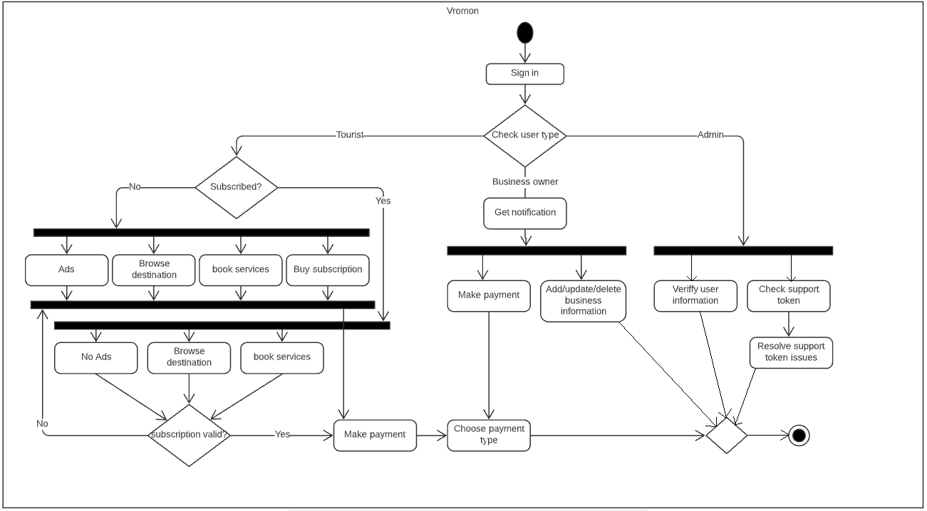

**Figure: Activity Diagram**

**12.0 Risk Analysis:**

|  |  |  |  |  |
| --- | --- | --- | --- | --- |
| **Risks** | **Probability** | **Impact** | **Rating** | **RMMM** |
| Project Manager Availability | 20% | 3 | Medium | R-1 |
| Schedule slips | 40% | 1 | High | R-2 |
| System goes hour | 50% | 3 | Medium | R-3 |
| Project cancelled | 40% | 4 | Low | R-4 |
| Programmers doesn’t have good experience | 30% | 3 | Medium | R-5 |
| Late delivery | 50% | 3 | Medium | R-6 |
| Customer Participation in Beta Testing | 30% | 4 | Low | R-7 |

**13.0 Budget for the project** :

Description Cost Assumptions

Site launch(hosting) 10,000 BDT

Maintenance (1 year) 25,000 BDT

Developers 1,00,000 BDT

Grand Total 1,35,000 BDT

So from the above calculation

Total Budget is = 1, 35,000 BDT

**14.0 Conclusion:** Lastly, after executing or completing a project module, we will get user feedback. Vromon software should provide security assurance. This project will contain customer iteration with hotels and travel businesses, and project management must quantify, objectify, separate, and allocate roles effectively. Given the total project timeline of 9-10 months, the most difficult component of this project is maintaining on track and finishing the task on time. People nowadays look for travel-related information on the internet since it is the most accessible and convenient way to obtain information. In Bangladesh, there are a lot of online travel companies. Our intended system is a web-based application that will incorporate services required by visitors as well as travel-related commercial entities. It is not only for visitors; it will also serve as a hosting platform for hotel or property owners, as well as owners of buses, cars, trains, or airlines.